DS LAB_03
Sir Shafique Rehman
Muhammad Fazeel
24K-0919

Task # 1:

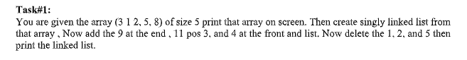

Code:
#include<iostream>
using namespace std;

class Node {
public:
int data;
Node *next;
Node(int val){
data = val;
next = NULL;
}
};

class LinkedList{
private:
Node *head;
Node *tail;
public:

LinkedList(){
head = tail = NULL;
}

void insertAtHead(int val){
Node *newNode = new Node(val);
if(head == NULL){
head = tail = newNode;
return;
}
else{
newNode->next = head;
head = newNode;
}
}

void insertAtTail(int val){
Node *newNode = new Node(val);
if(head == NULL){
head = tail = newNode;
return;
}
else{
tail->next = newNode;
tail = newNode;
}
}

void deleteAtTail(){
if(head == NULL){
cout << "\nLinked list in empty: ";
return;
}
else if(head == tail){
delete head;
head = tail = NULL;
}
else{
Node *temp = head;
while (temp->next != tail)
{
temp = temp->next;
}
delete tail;
tail = temp;
temp->next = NULL;
}
}

void deleteAtHead() {
if( head == NULL) {
cout << "\nLinked list in empty: ";
return;
}
else if(head == tail){
delete head;
head = tail = NULL;
return;
}
else{
Node *temp = head;
head = head->next;
delete temp;
}
}

void print(){
Node *temp = head;
while (temp != NULL)
{
cout << temp->data << " => ";
temp = temp->next;
}
cout << "NULL" << endl;
}

void insertAtPosition(int value , int pos){
if (pos < 0) {
cout << "\nInvalid position.";
return;
}
if (pos == 0) {
insertAtHead(value);
return;
}

Node *temp = head;
int currentIndex = 0;

while (temp != NULL && currentIndex < pos - 1) {
temp = temp->next;
currentIndex++;
}
if (temp == NULL) {
cout << "\nPosition out of bounds.";
return;
}

Node *newNode =new Node(value);
newNode->next= temp->next;
temp->next = newNode;

if (newNode->next == NULL) {
tail = newNode;
}
}
void deleteByValue(int val){
Node *temp = head;
Node *prev = NULL;
int found = 0;
while (temp != NULL)
{
if(temp->data == val){
found = 1;
break;
}
prev = temp;
temp = temp->next;
}
if(found == 0){
cout << "\nValue is not present. ";
return;
}

if(prev == NULL){
deleteAtHead();
}
else if(temp->next == NULL){
deleteAtTail();
}
else {
prev->next = temp->next;
delete temp;
}
}
~LinkedList() {
Node *current = head;
while (current != NULL) {
Node *nextNode = current->next;
delete current;
current = nextNode;
}
}

};

int main(){
int arr[5] = {3, 1, 2, 5, 8};

cout << "\nArray elements: ";

for (int i = 0; i < 5; i++)
{
cout << arr[i] << " ";
}

LinkedList list;
for (int i = 0; i < 5; i++)
{
list.insertAtTail(arr[i]);
}

cout << "\nNew linked list: \n";
list.print();

list.insertAtTail(9);

cout << "\nInserting value = 11, at position 3: \n";
list.insertAtPosition(11, 3);
list.print();

list.insertAtHead(4);

cout << "\nAfter deleting values 1, 2, 5\n";
list.deleteByValue(1);
list.deleteByValue(2);
list.deleteByValue(5);

list.print();
}
OUTPUT:

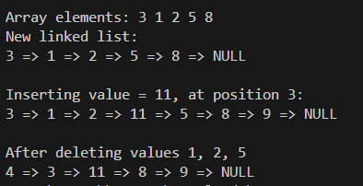

Task # 2:

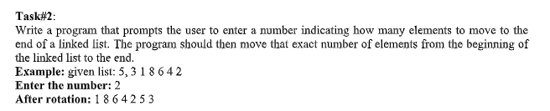

Code:
#include<iostream>
using namespace std;

class Node {
public:
int data;
Node *next;
Node(int val){
data = val;
next = NULL;
}
};

class LinkedList{
private:
Node *head;
Node *tail;
public:

LinkedList(){
head = tail = NULL;
}

void insertAtHead(int val){
Node *newNode = new Node(val);
if(head == NULL){
head = tail = newNode;
return;
}
else{
newNode->next = head;
head = newNode;
}
}

void insertAtTail(int val){
Node *newNode = new Node(val);
if(head == NULL){
head = tail = newNode;
return;
}
else{
tail->next = newNode;
tail = newNode;
}
}

void deleteAtTail(){
if(head == NULL){
cout << "\nLinked list in empty: ";
return;
}
else if(head == tail){
delete head;
head = tail = NULL;
}
else{
Node *temp = head;
while (temp->next != tail)
{
temp = temp->next;
}
delete tail;
tail = temp;
temp->next = NULL;
}
}

void deleteAtHead() {
if( head == NULL) {
cout << "\nLinked list in empty: ";
return;
}
else if(head == tail){
delete head;
head = tail = NULL;
return;
}
else{
Node *temp = head;
head = head->next;
delete temp;
}
}

void print(){
Node *temp = head;
while (temp != NULL)
{
cout << temp->data << " => ";
temp = temp->next;
}
cout << "NULL" << endl;
}

void moveToEnd(int number){
Node *temp = head;
while (number--)
{
tail->next = temp;
tail = temp;
temp = temp->next;
tail->next = NULL;
}
head = temp;
}

~LinkedList() {
Node *current = head;
while (current != NULL) {
Node *nextNode = current->next;
delete current;
current = nextNode;
}
}
};

int main(){
int number;
cout << "\nEnter the no of elements to move.";
cin >> number;

LinkedList list;
list.insertAtTail(1);
list.insertAtTail(2);
list.insertAtTail(3);
list.insertAtTail(4);

list.print();
list.moveToEnd(number);
list.print();
}
Output:
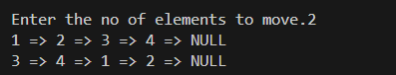

Task # 3:
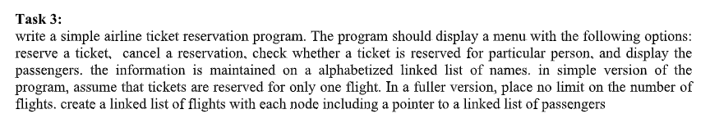
Code:
#include<iostream>
using namespace std;

class Node{
public:
string name;
Node *next;
Node(string val){
this->name = val;
next = NULL;
}
};

class Flight{
private:
Node *head;
int capacity;
int booked;
public:

Flight(){
head = NULL;
capacity = 200;
booked = 0;
}

void cancelReservation (string name) {
if (head == NULL) {
cout << "No passengers exist to cancel.\n";
return;
}
if(head->name == name) {
Node *temp = head;
head = head->next;
delete temp;
cout << "\nSeat has been cancelled of " << name << endl;
booked--;
return;
}

Node *temp = head;
while (temp->next != NULL && temp->next->name != name)
{
temp = temp->next;
}

if(temp->next == NULL) {
cout << "\nNo reservation found for " << name << endl;
}
else {
Node *todeleted = temp->next;
temp->next = todeleted->next;
delete todeleted;
booked--;
cout << "\nReservation canceled for " << name << endl;
}
}

void isticketReserved (string name) {
Node *temp = head;
while (temp != NULL)
{
if (temp->name == name) {
cout << "\nSeat with this name is booked: \n";
return;
}
temp = temp->next;
}
cout << "\nSeat with this name is not booked: \n";
}

void displayPassengers() {
if (head == NULL) {
cout << "\nNo one booked yet.\n";
return;
}
cout << "\n========== Passenger List ==========\n";
Node* temp = head;
int count = 1;
while (temp != NULL) {
cout << count++ << ". " << temp->name << endl;
temp = temp->next;
}
cout << "------------------------------------\n";
cout << "Total booked: " << booked << " / " << capacity << endl;
cout << "====================================\n";
}

void reserveTicket (string name) {
if(booked >= capacity){
cout << "\nNo more seats: ";
return;
}

Node *newNode = new Node(name);

if (head == NULL || name < head->name) {
newNode->next = head;
head = newNode;
booked++;
cout << "\nTicket has been reserved for " << name << endl;
return ;
}
else{
Node *temp = head;

while (temp->next != NULL && temp->next->name < name)
{
temp = temp->next;
}

newNode->next = temp->next;
temp->next = newNode;
booked++;
cout << "\nTicket has been reserved for "<< name;
}
}

~Flight() {
Node *current = head;
while (current != NULL) {
Node *nextNode = current->next;
delete current;
current = nextNode;
}
}
};

int main(){

Flight f1;

int choice = 0;

cout << "\n---------------Airline Ticket Reservation-----------------\n";
while (choice != 5){

cout << "\n1. Reserve a ticket: ";
cout << "\n2. Cancel a ticket: ";
cout << "\n3. Check reserved ticket: ";
cout << "\n4. Display Passengers: ";
cout << "\n5. Exit";
cout << "\nEnter the choice: ";
cin >> choice;
string name;
switch (choice)
{
case 1:
cout << "\nEnter the name: ";
cin >> name;
f1.reserveTicket(name);
break;

case 2:
cout << "\nEnter the name: ";
cin >> name;
f1.cancelReservation(name);
break;

case 3:
cout << "\nEnter the name: ";
cin >> name;
f1.isticketReserved(name);
break;

case 4:
f1.displayPassengers();
break;

case 5:
return 0;
default:
cout << "\nInvalid command: ";
break;
}
}
}

Output:
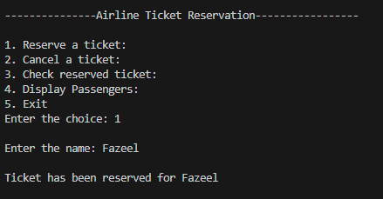
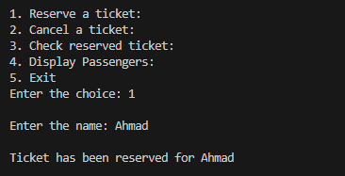
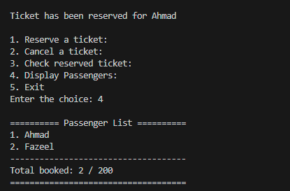
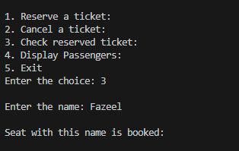
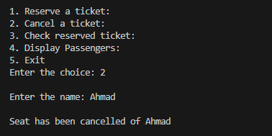

Task # 4:
Solve the following problem using a Singly Linked List.
Given a Linked List of integers, write a function to modify the linked list such that all even numbers appear before all the odd numbers in the modified linked list. Also, keep the order of even and odd numbers same.
Code:
#include<iostream>
using namespace std;

class Node{
public:
int data;
Node *next;
Node(int value){
data = value;
next = NULL;
}
};

class LinkedList {
public:
Node *head;
Node *tail;

LinkedList(){
head = tail = NULL;
}

void insertAtHead(int val){
Node *newNode = new Node(val);
if(head == NULL){
head = tail = newNode;
return;
}
else{
newNode->next = head;
head = newNode;
}
}
void insertAtTail(int val){
Node *newNode = new Node(val);
if(head == NULL){
head = tail = newNode;
return;
}
else{
tail->next = newNode;
tail = newNode;
}
}
void evenBeforeOdd(){
Node *prevodd = NULL;
Node *preveven = NULL;
Node *firstOdd = NULL;
Node *firsteven = NULL;
Node *temp = head;

while (temp != NULL){
if (temp->data % 2 == 0) {
if(!firsteven){
firsteven = temp;
preveven = temp;
}
else {
preveven->next = temp;
preveven = temp;
}
}
else {
if(!firstOdd){
firstOdd = temp;
prevodd=temp;
}
else{
prevodd->next = temp;
prevodd = temp;
}
}
temp = temp->next;
}

if (!firsteven || !firstOdd) return;

preveven->next = firstOdd;
prevodd->next = NULL;

head = firsteven; // reassigning the head again
}

void print(){
Node *temp = head;
while (temp != NULL)
{
cout << temp->data << " => ";
temp = temp->next;
}
cout << "NULL" << endl;
}
~LinkedList() {
Node *current = head;
while (current != NULL) {
Node *nextNode = current->next;
delete current;
current = nextNode;
}
}

};
int main()
{
LinkedList ll;
// Input: 17-15-8-12-10-5-4-1-7-6-NULL
cout << "\n<------------------------List 1:--------------------------------->\n";
ll.insertAtTail(17);
ll.insertAtTail(15);
ll.insertAtTail(8);
ll.insertAtTail(12);
ll.insertAtTail(10);
ll.insertAtTail(5);
ll.insertAtTail(4);
ll.insertAtTail(1);
ll.insertAtTail(7);
ll.insertAtTail(6);
ll.print();
ll.evenBeforeOdd();
ll.print();

cout << "\n<------------------------List 2:--------------------------------->\n";
LinkedList list2;
list2.insertAtTail(8);
list2.insertAtTail(10);
list2.insertAtTail(12);
list2.print();
list2.evenBeforeOdd();
list2.print();

cout << "\n<------------------------List 3:--------------------------------->\n";
LinkedList list3;
list3.insertAtTail(1);
list3.insertAtTail(3);
list3.insertAtTail(5);
list3.insertAtTail(7);
list3.print();
list3.evenBeforeOdd();
list3.print();

return 0;
}

Output:
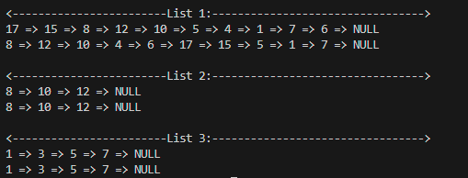

Task # 5:
Solve the following problem using a Singly Linked List.
Given a Linked List of integers or string, write a function to check if the entirety of the linked list is a palindrome or not.
Code:
#include<iostream>
using namespace std;

template <typename T>
class Node{
public:
T data;
Node *next;

Node(T val) {
data = val;
next = NULL;
}
};

template <typename T>
class LinkedList {
public:
Node<T> *head;
Node<T> *tail;
LinkedList(){
head = tail = NULL;
}
Node<T>* reverse(Node<T>* head) {
Node<T>* prev = NULL;
Node<T>* curr = head;
Node<T>* next = NULL;

while (curr != NULL) {
next = curr->next;
curr->next = prev;
prev = curr;
curr = next;
}
return prev;
}
bool isPalindrome(){
if (!head || !head->next) return true;
Node<T> *slow = head;
Node<T> *fast = head;
while (fast != NULL && fast->next != NULL)
{
slow = slow->next;
fast = fast->next->next;
}
Node<T> *firstpart = head;
Node<T> *secondpart = reverse(slow);
while(secondpart != NULL){
if(firstpart->data != secondpart->data){
return false;
}
firstpart = firstpart->next;
secondpart = secondpart->next;
}
return true;
}
void insertAtHead(T val){
Node<T> *newNode = new Node<T>(val);
if(head == NULL){
head = tail = newNode;
return;
}
else{
newNode->next = head;
head = newNode;
}
}
void print(){
Node<T> *temp = head;
while (temp != NULL)
{
cout << temp->data << " => ";
temp = temp->next;
}
cout << "NULL" << endl;
}
~LinkedList() {
Node<T> *current = head;
while (current != NULL) {
Node<T> *nextNode = current->next;
delete current;
current = nextNode;
}
}
};
int main()
{
LinkedList<int> list;
list.insertAtHead(1);
list.insertAtHead(0);
list.insertAtHead(2);
list.insertAtHead(0);
list.insertAtHead(1);

if(list.isPalindrome()){
cout << "\nList # 1 is PALIDROME: \n";
}
else {
cout << "\nList # 1 is not PALINDROME: \n";
}
list.print();

LinkedList<char> list2;
list2.insertAtHead('b');
list2.insertAtHead('o');
list2.insertAtHead('r');
list2.insertAtHead('r');
list2.insertAtHead('o');
list2.insertAtHead('w');
list2.insertAtHead('o');
list2.insertAtHead('r');
list2.insertAtHead('r');
list2.insertAtHead('o');
list2.insertAtHead('b');

if(list2.isPalindrome()){
cout << "\nList # 2 is PALIDROME: \n";
}
else {
cout << "\nList # 2 is not PALINDROME: \n";
}

list2.print();
return 0;
}

Output:

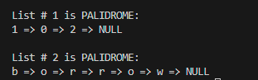

Task # 6:
Delete a value from any position (not the first one only) from the singly linked list if it’s present in the list otherwise show a message to the user that the value is not present in the list.

Code:
#include<iostream>
using namespace std;

class Node{
public:
int data;
Node *next;
Node(int value){
data = value;
next = NULL;
}
};

class LinkedList {
public:
Node *head;
Node *tail;
LinkedList(){
head = tail = NULL;
}

void insertAtTail(int val){
Node *newNode = new Node(val);
if(head == NULL){
head = tail = newNode;
return;
}
else{
tail->next = newNode;
tail = newNode;
}
}

bool search(int val){
Node *temp = head;
while (temp != NULL)
{
if (temp->data == val) return true;
temp = temp->next;
}
return false;
}
void deleteByValue(int val){
if(!search(val)){
cout << "\nKey does not exist: ";
return;
}
while (head != NULL && head->data == val)
{
Node *temp2 = head;
head = head->next;
delete temp2;
}
Node *temp = head;

while (temp != NULL && temp->next != NULL)
{
if(temp->next->data == val) {
Node *temp2 = temp->next;
temp->next = temp2->next;
delete temp2;
}
else{
temp = temp->next;
}
}
}

void print(){
Node *temp = head;
while (temp != NULL)
{
cout << temp->data << " => ";
temp = temp->next;
}
cout << "NULL" << endl;
}

~LinkedList() {
Node *current = head;
while (current != NULL) {
Node *nextNode = current->next;
delete current;
current = nextNode;
}
}

};
int main()
{
LinkedList list;
list.insertAtTail(1);
list.insertAtTail(2);
list.insertAtTail(3);
list.insertAtTail(3);
list.insertAtTail(3);
list.insertAtTail(4);
cout << "\nBefore Deletion: \n";
list.print();
list.deleteByValue(3);
cout << "\nAfter deletion: \n";
list.print();
return 0;
}

Output:
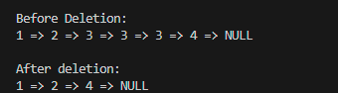

Task # 7:
Create a circular link list and perform the mentioned tasks.
a. Insert a new node at the end of the list.
b. Insert a new node at the beginning of list.
c. Insert a new node at given position.
d. Delete any node.
e. Print the complete circular link list.
Code:

#include<iostream>
using namespace std;

class Node {
public:
int data;
Node *next;

Node(int val) {
this->data = val;
next = NULL;
}
};

class CircularList {
public:
Node *head;
Node *tail;

CircularList() {
head = tail = NULL;
}

void insertAtTail( int val ) {
Node *newNode = new Node (val);
if (head == NULL) {
head = tail = newNode;
tail->next = head;
return ;
}
tail->next = newNode;
tail = newNode;
newNode->next = head;
}
void insertAtHead ( int val ) {
Node *newNode = new Node (val);

if (head == NULL) {
head = tail = newNode;
tail->next = head;
return ;
}
newNode->next = head;
head = newNode;
tail->next = head;
}

void insertAtposition (int val , int pos) {
if (pos < 0) {
cout << "\nInvalid position: ";
return ;
}
if (pos == 0) {
insertAtHead (val);
return;
}
Node *temp = head;
int currentIndex = 0;

while ( temp != tail && currentIndex < pos - 1) {
temp = temp->next;
currentIndex++;
}

if (temp == tail) {
insertAtTail (val);
return ;
}

Node *newNode = new Node (val);
newNode->next = temp->next;
temp->next = newNode;
}

void deleteNode (int pos ) {
if (head == NULL) {
cout << "\nList is empty: ";
return ;
}
if(pos == 0) {
if (head == tail ){
delete head;
head = tail = NULL;
return;
}
Node *temp = head;
head = head->next;
tail->next = head;
delete temp;
return;
}

Node *temp = head;
int count = 0;
while (temp != tail && count < pos - 1) {
temp = temp->next;
count++;
}
if (temp->next == head) {
cout << "\nInvalid position!";
return;
}
Node *toDelete = temp->next;

if (toDelete == tail) {
tail = temp;
}

temp->next = toDelete->next;
delete toDelete;
}

void print () {
Node *temp = head;
do {
cout << temp->data << " => ";
temp = temp->next;
} while (temp != head);
cout << " (head again): \n";
}
~LinkedList() {
if (head == NULL) return;

Node *current = head;
Node *nextNode;
tail->next = NULL;

while (current != NULL) {
nextNode = current->next;
delete current;
current = nextNode;
}
}

};

int main()
{
CircularList cirList;
cirList.insertAtTail(1);
cirList.insertAtTail(2);
cirList.insertAtTail(3);
cirList.insertAtTail(4);

cirList.print();
cirList.insertAtHead(9);
cirList.insertAtTail(22);
cirList.print();

cout << "\nInserting value = 100, at position = 3 \n";
cirList.insertAtposition (100, 3);
cirList.print();
cout << "\nDeleting Node at index 4 :\n";
cirList.deleteNode(4);
cirList.print();
return 0;
}

Output:
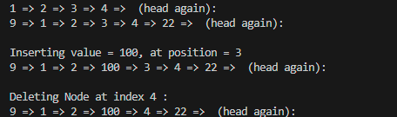

Task # 8:
Give an efficient algorithm for concatenating two doubly linked lists L and M, with head and tail preserved nodes, into a single list that contains all the nodes of L followed by all the nodes of M.
Code:
#include<iostream>
using namespace std;

class Node{
public:
int data;
Node *next;
Node *prev;
Node(int data){
this->data = data;
next = NULL;
prev = NULL;
}
};

class DoublyList{
public:
Node *head;
Node *tail;

DoublyList(){
head = tail = NULL;
}

void push_front(int val){
Node *newNode = new Node(val);
if(head == NULL){
head = tail = newNode;
return;
}
else{
newNode->next = head;
head->prev = newNode;
head = newNode;
}
}

void push_back(int val){
Node *newNode = new Node(val);
if(head == NULL){
head = tail = newNode;
return;
}
else{
newNode->prev = tail;
tail->next = newNode;
tail = newNode;
}
}

void pop_front(){
if (head == NULL){
cout << "\nList in empty: ";
return;
}
Node *temp = head;

if(head == tail){
head = tail = NULL;
}
else{
head = head->next;
head->prev = NULL;
}
delete temp;
}

void pop_back() {
if (head == NULL) {
cout << "\nList is empty.";
return;
}
Node* temp = tail;

if (head == tail) {
head = tail = NULL;
} else {
tail = tail->prev;
tail->next = NULL;
}
delete temp;
}

void print(){
Node *temp = head;
while (temp != NULL)
{
cout << temp->data << " <==> ";
temp = temp->next;
}
cout << "NULL\n";
}
void mergeList(DoublyList &L, DoublyList &K) {
if(K.head == NULL) {
return ;
}
if (L.head == NULL) {
L.head = K.head;
L.tail = K.tail;
K.head = K.tail = NULL;
return;
}

L.tail->next = K.head;
K.head->prev = L.tail;
L.tail = K.tail;

K.head = K.tail = NULL;

}
~LinkedList() {
Node *current = head;
while (current != NULL) {
Node *nextNode = current->next;
delete current;
current = nextNode;
}
}

};

int main()
{
DoublyList L;
L.push_back(1);
L.push_back(2);
L.push_back(3);
cout << "\nList-L \n";
L.print();

DoublyList W;
W.push_back(4);
W.push_back(5);
W.push_back(6);
cout << "\nList-W \n";
L.print();
L.mergeList(L,W);

cout << "\nAfter merging both the lists: ";
L.print();
return 0;
}

Output:
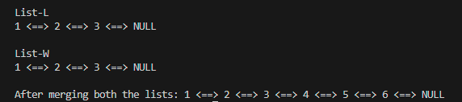

Task # 9:
Given a linked list, you have to perform the following task:
1. Extract the alternative nodes starting from second node.
2. Reverse the extracted list.
3. Append the extracted list at the end of the original list.
Code:
#include<iostream>
using namespace std;

class Node{
public:
int data;
Node *next;
Node(int val){
data = val;
next = NULL;
}
};

class LinkedList{
private:
Node *head;
Node *tail;
public:

LinkedList(){
head = tail = NULL;
}

void insertAtHead(int val) {
Node *newNode = new Node(val);
if(head == NULL){
head = tail = newNode;
return;
}
else{
newNode->next = head;
head = newNode;
}
}

void insertAtTail(int val){
Node *newNode = new Node(val);
if(head == NULL){
head = tail = newNode;
return;
}
else{
tail->next = newNode;
tail = newNode;
}
}

Node* reverseList(Node* head) {
Node* prev = nullptr;
Node* curr = head;
Node* next = nullptr;

while (curr != nullptr) {
next = curr->next;
curr->next = prev;
prev = curr;
curr = next;
}
return prev;
}

void reverseAlternateNodes() {
if(head == NULL) {
return ;
}
int count = 0;
Node *originalhead = NULL;
Node *originallast = NULL;
Node *extractedhead = NULL;
Node *extractedlast = NULL;
Node *temp = head;

while (temp != NULL) {
Node *nextNode = temp->next;
temp->next = NULL;

if (count % 2 == 0){
if(!originalhead)
originalhead = originallast = temp;

else {
originallast->next = temp; originallast = temp;
}
}
else {
if(!extractedhead)
extractedhead = extractedlast = temp;

else {
extractedlast->next = temp; extractedlast = temp;
}
}

temp = nextNode;
count++;
}

extractedhead = reverseList(extractedhead);
if (originallast) {
originallast->next = extractedhead;
}
head = originalhead;
Node* t = originallast;
while (t!=NULL && t->next != NULL) {
t = t->next;
}
tail = t;
head = originalhead;
}

void print(){
Node *temp = head;
while (temp != NULL)
{
cout << temp->data << " => ";
temp = temp->next;
}
cout << "NULL" << endl;
}

~LinkedList() {
Node *current = head;
while (current != NULL) {
Node *nextNode = current->next;
delete current;
current = nextNode;
}
}

};

int main()
{
LinkedList list;
list.insertAtTail(10);
list.insertAtTail(4);
list.insertAtTail(9);
list.insertAtTail(1);
list.insertAtTail(3);
list.insertAtTail(5);
list.insertAtTail(9);
list.insertAtTail(4);
cout << "\nBefore reversing Alternates nodes: \n";
list.print();
list.reverseAlternateNodes();
cout << "\nAfter reversing Alternates nodes: \n";
list.print();

}

Output:
